Chapter 4, Solution 45.

Find the Thevenin equivalent of the circuit in Fig. 4.112 as seen by looking into terminals a and b.

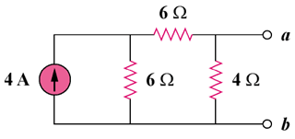

Figure 4.112
For Prob. 4.45.

Solution

For R_{N}, consider the circuit in Fig. (a).

(b)

4 Ω

6 Ω

6 Ω

I_{N}

4A

(a)

4 Ω

6 Ω

6 Ω

R_{N}

R_{N} = (6 + 6)||4 = 3 Ω

For I_{N}, consider the circuit in Fig. (b). The 4-ohm resistor is shorted so that 4-A current is equally divided between the two 6-ohm resistors. Hence,

I_{N} = 4/2 = 2 A and

V_{Thev} = 2x3 = 6 V

